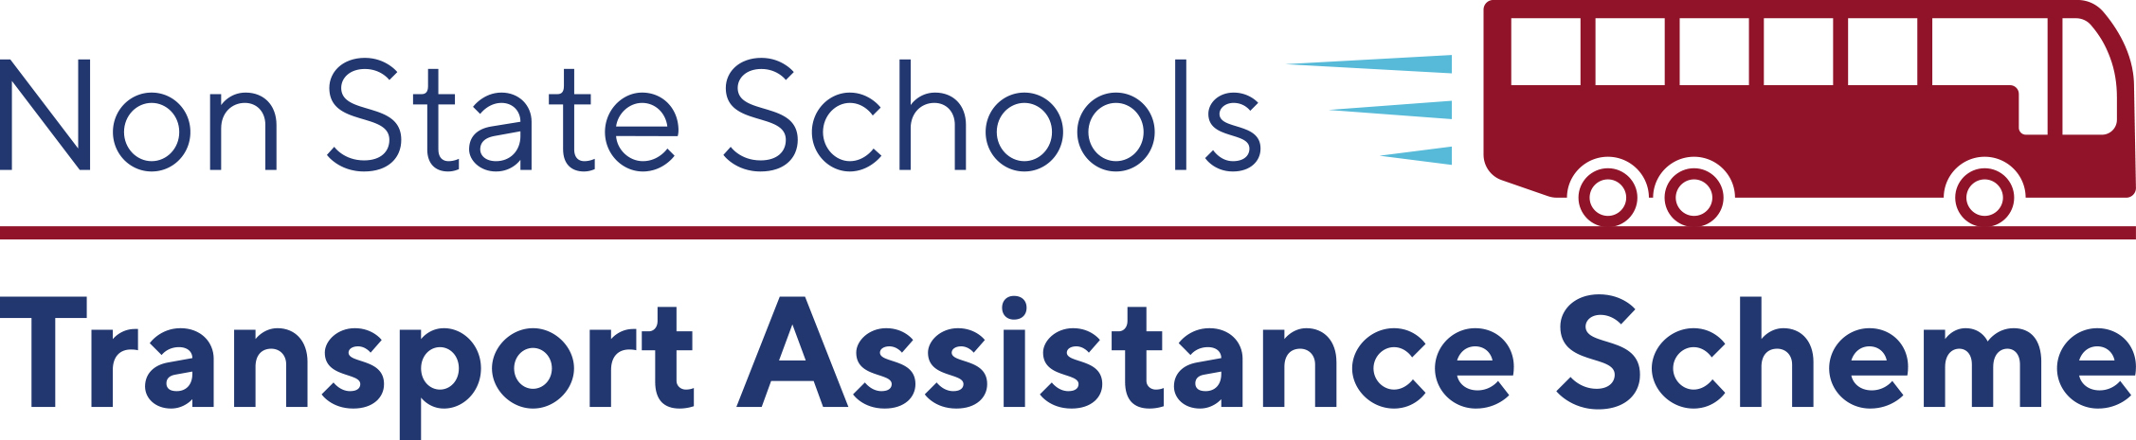

**Student Travel Rebates**

**Semester 2**

Visit our website to see if you qualify for our financial

assistance to help with the cost of transport and

**apply at** [**SchoolTransport.com.au**](https://schooltransport.com.au/) **during October.**

**Late applications cannot be accepted after 31st October.**

  

**Students With Disability**

* Was your child **included on the latest Commonwealth Census** as a student with a disability requiring **supplementary, substantial or extensive adjustments**?
* Does your child’s **Personalised Learning Plan** confirm their transport needs are demonstrably different to those of their same aged peers by reason of their disability?
* Has your school’s learning support teacher assessed your child’s **Travel Capability Rating** of ‘semi-independent’ or more dependent?

**Bus Fare Assistance**

* Does your child attend a **non-state school outside the Brisbane City Council** boundary?
* Does your **family** spend more than **$25/week\*** on bus/ferry fares to and from school (**\***$15/week if you, the parent, hold a concession card)?
* Does your child travel on a **publicly available service** not owned or chartered by the school?